**Ex:** 8

**Date:** 22/11/2020

**Aim:**

Write a Python program to get a list, sorted in increasing order by the last element in each tuple from a given list of non-empty tuples.

**Program:**

def l(n):

return n[-1]

def s(t):

return sorted(t, key=l)

print(s([(2,5),(1,2),(4,4),(2,3),(2,1)]))

**Output:**

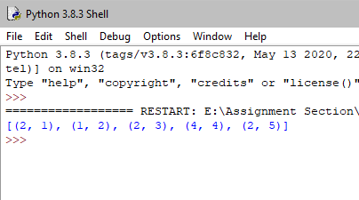

**Result:**

Thus sorting of tuple is done in increasing order is done in python.

**Link:**

<http://103.53.53.18/mod/vpl/forms/submissionview.php?id=317&userid=1652>